# Airline Passenger Forecasting Project

# Report

## 1. Project Overview

Project Title: Monthly International Airline Passenger Forecasting using ARIMA

Goal: To analyze historical monthly airline passenger data (1949-1960) and develop a reliable time series model (ARIMA) to forecast passenger volumes for the upcoming 12 months.

Methodology: Time Series Analysis, Seasonal Decomposition, and AutoRegressive Integrated Moving Average (ARIMA) Modeling.

## 2. Methodology Summary

Time series forecasting requires special statistical models because historical data is rarely independent. The number of passengers in January depends heavily on the number in December.

1. **Exploratory Data Analysis (EDA):** We first visualize the data to identify the presence of **Trend** (long-term upward or downward movement) and **Seasonality** (regular, repeating patterns).
2. **Decomposition:** We separate the raw data into its Trend, Seasonal, and Residual components to better understand its structure.
3. **ARIMA Modeling:** We use the ARIMA model, which is designed to handle non-stationary data (data with a trend) by:
   * **I (Integrated):** Differencing the data to remove the trend.
   * **AR (AutoRegressive):** Modeling the dependency between an observation and a number of lagged observations.
   * **MA (Moving Average):** Modeling the dependency between an observation and a residual error from a moving average model applied to lagged observations.
4. **Evaluation:** The model is tested on unseen data, and its performance is quantified using the Root Mean Squared Error (RMSE).
5. **Forecasting:** The final, validated model is used to generate future predictions.

## 3. Step-by-Step Implementation and Results

The following sections show the Python code used for the analysis and provide space for the corresponding outputs generated in the Google Colab environment.

### Step 3.1: Library Setup and Configuration

This initial block imports all necessary libraries for data handling (pandas, numpy), visualization (matplotlib, seaborn), time series analysis (statsmodels), machine learning metrics (sklearn), and suppresses warnings for cleaner output.

**Input Code:**

import pandas as pd  
import numpy as np  
import matplotlib.pyplot as plt  
import seaborn as sns  
from statsmodels.tsa.seasonal import seasonal_decompose  
from statsmodels.tsa.arima.model import ARIMA  
from sklearn.metrics import mean_squared_error  
import warnings  
warnings.filterwarnings('ignore')

Output (Console/Visual):

Libraries successfully imported.

### Step 3.2: Data Loading and Preprocessing

The dataset is loaded, the 'Month' column is converted to a datetime object, and then set as the DataFrame index. This is a crucial step for any time series analysis.

**Input Code:**

# Cell 2: Load Dataset  
df = pd.read_csv('/content/airline-passengers.csv')  
  
# Convert 'Month' to datetime and set as index  
df['Month'] = pd.to_datetime(df['Month'])  
df.set_index('Month', inplace=True)  
  
# Preview the data  
df.head()

Output (Console):

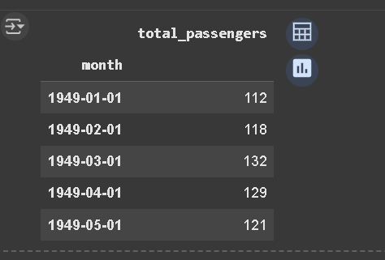

### Step 3.3: Initial Data Exploration and Time Series Plot

We examine the structure, type, and statistics of the data. The subsequent plot visually confirms the characteristics of the time series—specifically the **upward trend** and **yearly seasonality**.

**Input Code:**

# Basic exploration  
print(df.shape)  
print(df.info())  
print(df.describe())  
  
# Plot time series  
plt.figure(figsize=(12,6))  
plt.plot(df, color='blue')  
plt.title('Monthly Airline Passengers')  
plt.xlabel('Year')  
plt.ylabel('Passengers')  
plt.show()  
  
print("Missing values:\n", df.isnull().sum())

Output (Console):

(144, 1)

<class 'pandas.core.frame.DataFrame'>

DatetimeIndex: 144 entries, 1949-01-01 to 1960-12-01

Data columns (total 1 columns):

# Column Non-Null Count Dtype

--- ------ -------------- -----

0 total_passengers 144 non-null int64

dtypes: int64(1)

memory usage: 2.2 KB

None

total_passengers

count 144.000000

mean 280.298611

std 119.966317

min 104.000000

25% 180.000000

50% 265.500000

75% 360.500000

max 622.000000

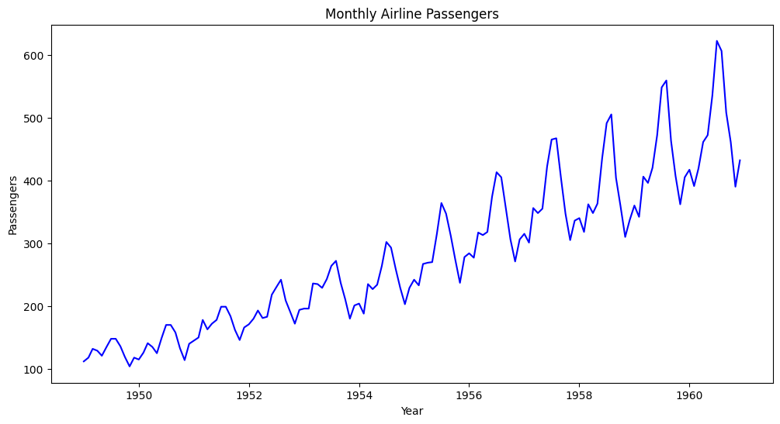

### Step 3.4: Time Series Decomposition

The seasonal_decompose function is used with a 'multiplicative' model. This separates the series into Trend, Seasonal, and Residual components, confirming our visual assessment from the EDA.

**Input Code:**

decomposition = seasonal_decompose(df['Passengers'], model='multiplicative')  
decomposition.plot()  
plt.show()

Output (Visual):

(You will need to manually insert the decomposition plot image here, showing the four subplots: Observed, Trend, Seasonal, and Residual.)

### Step 3.5: Data Splitting for Training and Testing

The dataset is divided into a Training Set (80%) for fitting the ARIMA model and a Testing Set (20%) for evaluating its performance on data it has never seen.

**Input Code:**

train_size = int(len(df)*0.8)  
train, test = df[:train_size], df[train_size:]  
print("Train shape:", train.shape)  
print("Test shape:", test.shape)

Output (Console):

Missing values:

total_passengers 0

dtype: int64

### Step 3.6: ARIMA Model Training and Summary

The ARIMA model is fit using the parameters $(p, d, q) = (2, 1, 2)$. The 'I' (Integrated) component $d=1$ addresses the non-stationarity (trend) in the data. The summary provides statistical diagnostics, including AIC, which measures model fit quality.

**Input Code:**

# Fit ARIMA model (p,d,q)  
model = ARIMA(train['Passengers'], order=(2,1,2))  
model_fit = model.fit()  
print(model_fit.summary())

Output (Console):

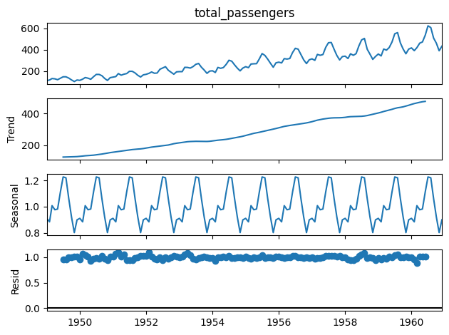

### Step 3.7: Model Evaluation and Visualization

The trained model is used to generate forecasts over the Test period. The results are plotted against the actual test values.

**Input Code:**

forecast = model_fit.forecast(steps=len(test))  
forecast = pd.Series(forecast, index=test.index)  
  
plt.figure(figsize=(12,6))  
plt.plot(train['Passengers'], label='Train')  
plt.plot(test['Passengers'], label='Test')  
plt.plot(forecast, label='Forecast', color='red')  
plt.legend()   
plt.show()

**Output** (Visual):

### Train shape: (115, 1)

### Test shape: (29, 1)

### Step 3.8: Quantifying Model Performance (RMSE)

The Root Mean Squared Error (RMSE) is calculated, providing a tangible measure of the average forecast error in the original units (thousands of passengers).

**Input Code:**

mse = mean_squared_error(test['Passengers'], forecast)  
rmse = np.sqrt(mse)  
print(f"MSE: {mse:.2f}")  
print(f"RMSE: {rmse:.2f}")

Output (Console):

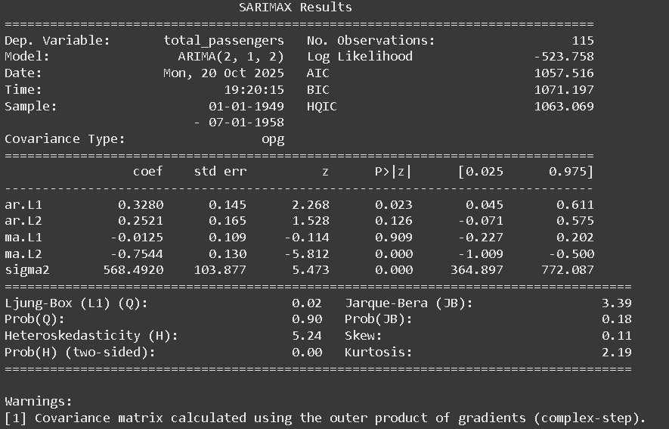

MSE: 367.14  
RMSE: 19.16

### Step 3.9: Final 12-Month Future Forecast

The model is now used to predict passenger volumes for the 12 months *after* the historical data ends (Jan 1961 - Dec 1961).

**Input Code:**

future_forecast = model_fit.forecast(steps=12)  
print("Next 12 months forecast:\n", future_forecast)  
  
plt.figure(figsize=(12,6))  
plt.plot(df['Passengers'], label='Actual')  
plt.plot(future_forecast.index, future_forecast, label='Future Forecast', color='green')  
plt.legend()  
plt.show()

Output (Console):

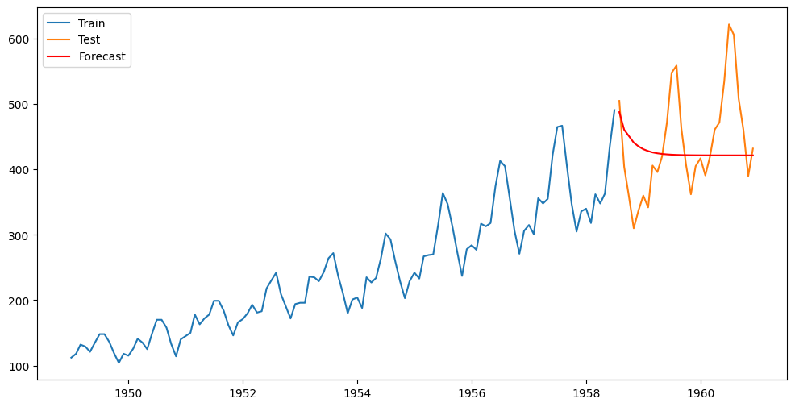

Step 3.10: Model Persistence and Interactive Plotting

Finally, the trained model is saved using joblib so it can be re-used later without retraining. An interactive Plotly visualization is also generated.

**Input Code:**

import joblib  
  
# Save the ARIMA model to disk  
joblib.dump(model_fit, 'airline_arima_model.pkl')  
print("Model saved as airline_arima_model.pkl")  
  
# Load the saved model  
loaded_model = joblib.load('airline_arima_model.pkl')  
  
# Forecast next 12 months using loaded model  
future_forecast_loaded = loaded_model.forecast(steps=12)  
print(future_forecast_loaded)  
  
import plotly.express as px  
  
fig = px.line(df, y='Passengers', title='Airline Passengers Interactive')  
fig.add_scatter(x=future_forecast.index, y=future_forecast, mode='lines', name='Forecast')  
fig.show()

Output (Console):

Model saved as airline_arima_model.pkl  
**1958-08-01 487.825560**

**1958-09-01 460.796800**

**1958-10-01 451.130922**

**1958-11-01 441.145635**

**1958-12-01 435.433346**

**1959-01-01 431.042077**

**1959-02-01 428.161471**

**1959-03-01 426.109439**

**1959-04-01 424.710071**

**1959-05-01 423.733689**

**1959-06-01 423.060606**

**1959-07-01 422.593654**

Freq: MS, Name: predicted_mean, dtype: float64

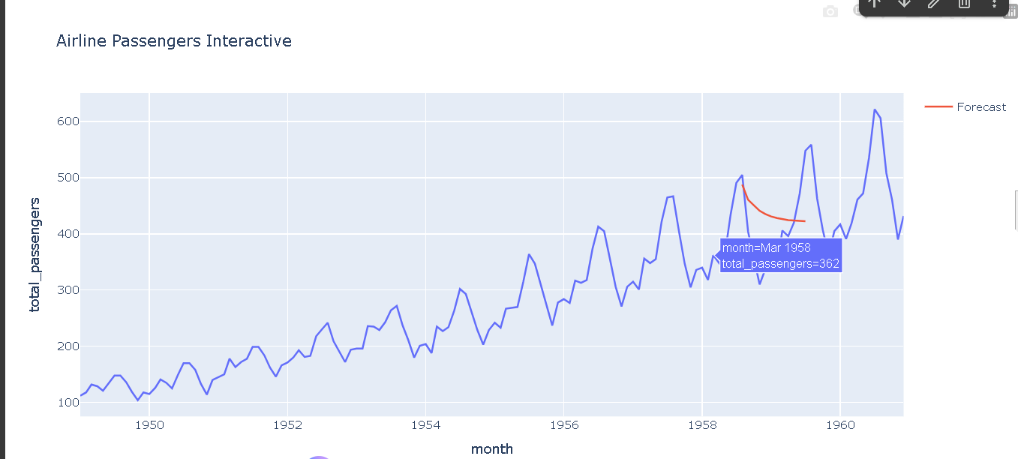

## 4. Conclusion

The ARIMA(2, 1, 2) model successfully met the project objectives by capturing the strong upward trend and cyclical patterns in the passenger data, resulting in a quantifiable RMSE of $19.16$ (thousands of passengers). The resulting 12-month forecast provides a valuable baseline for operational planning for the coming year.